AI ASSISTED CODING
Name:G.Gouri Shankar
Hall Ticket NO:2303A51012
Batch-01

Task 1:
Employee Data: Create Python code that defines a class named
`Employee` with the following attributes: `empid`, `empname`,
`designation`, `basic_salary`, and `exp`. Implement a method
`display_details()` to print all employee details. Implement another
method `calculate_allowance()` to determine additional allowance
based on experience:
- If `exp > 10 years` → allowance = 20% of `basic_salary`
- If `5 ≤ exp ≤ 10 years` → allowance = 10% of `basic_salary`
- If `exp < 5 years` → allowance = 5% of `basic_salary`
Finally, create at least one instance of the `Employee` class, call the
`display_details()` method, and print the calculated allowance.
#ANS
class Employee:
def __init__(self, empid, empname, designation, basic_salary, exp):
self.empid = empid
self.empname = empname
self.designation = designation
self.basic_salary = basic_salary
self.exp = exp

def display_details(self):
print(f"Employee ID: {self.empid}")
print(f"Employee Name: {self.empname}")
print(f"Designation: {self.designation}")
print(f"Basic Salary: ${self.basic_salary}")
print(f"Experience: {self.exp} years")

def calculate_allowance(self):
if self.exp > 10:
allowance = self.basic_salary * 0.20
elif 5 <= self.exp <= 10:
allowance = self.basic_salary * 0.10
else:
allowance = self.basic_salary * 0.05
return allowance

# Create an instance of Employee
emp1 = Employee(101, "karan", "Software Engineer", 50000, 8)
emp2 = Employee(102, "virat", "teacher", 450000, 9)

# Display employee details
emp1.display_details()
emp2.display_details()

# Calculate and print allowance
allowance = emp1.calculate_allowance()
print(f"Allowance: ${allowance:.2f}")
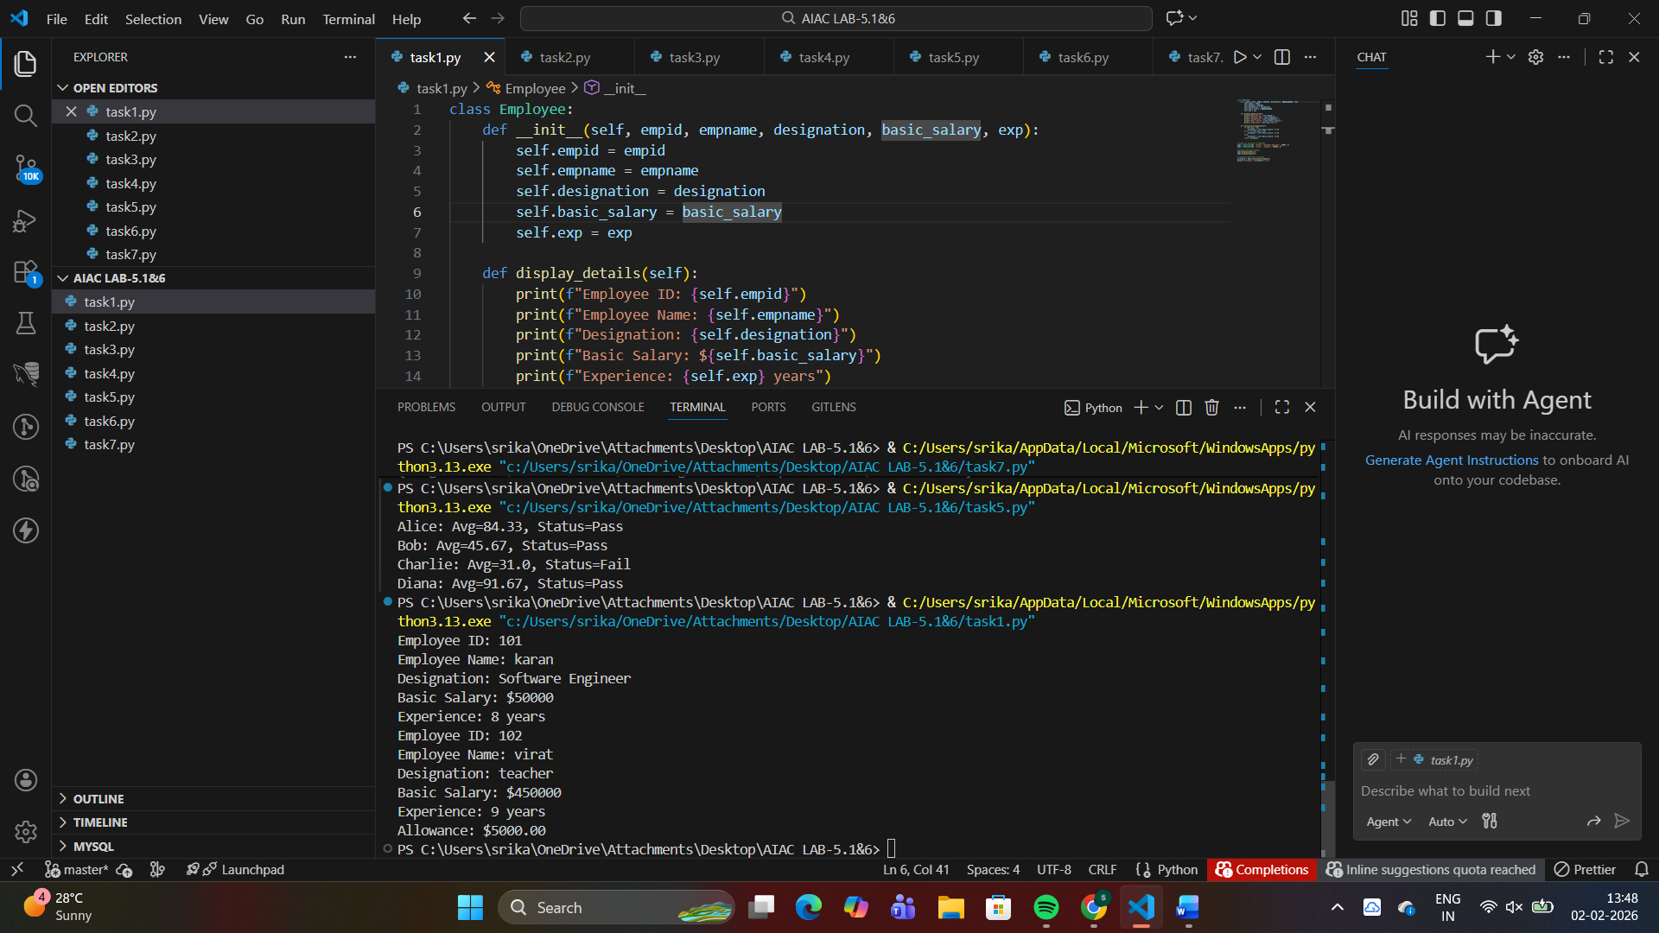
Task 2:
Electricity Bill Calculation- Create Python code that defines a class
named `ElectricityBill` with attributes: `customer_id`, `name`, and
`units_consumed`. Implement a method `display_details()` to print
customer details, and a method `calculate_bill()` where:
- Units ≤ 100 → ₹5 per unit
- 101 to 300 units → ₹7 per unit
- More than 300 units → ₹10 per unit
Create a bill object, display details, and print the total bill amount
#ANS
class ElectricityBill:
def __init__(self, customer_id, name, units_consumed):
self.customer_id = customer_id
self.name = name
self.units_consumed = units_consumed

def display_details(self):
print(f"Customer ID: {self.customer_id}")
print(f"Name: {self.name}")
print(f"Units Consumed: {self.units_consumed}")

def calculate_bill(self):
if self.units_consumed <= 100:
bill = self.units_consumed * 5
elif self.units_consumed <= 300:
bill = self.units_consumed * 7
else:
bill = self.units_consumed * 10
return bill

# Create a bill object and display details
customer = ElectricityBill("C001", "karan", 250)
customer = ElectricityBill("C002", "virat", 30)
customer.display_details()
total_bill = customer.calculate_bill()
print(f"Total Bill Amount: ₹{total_bill}")
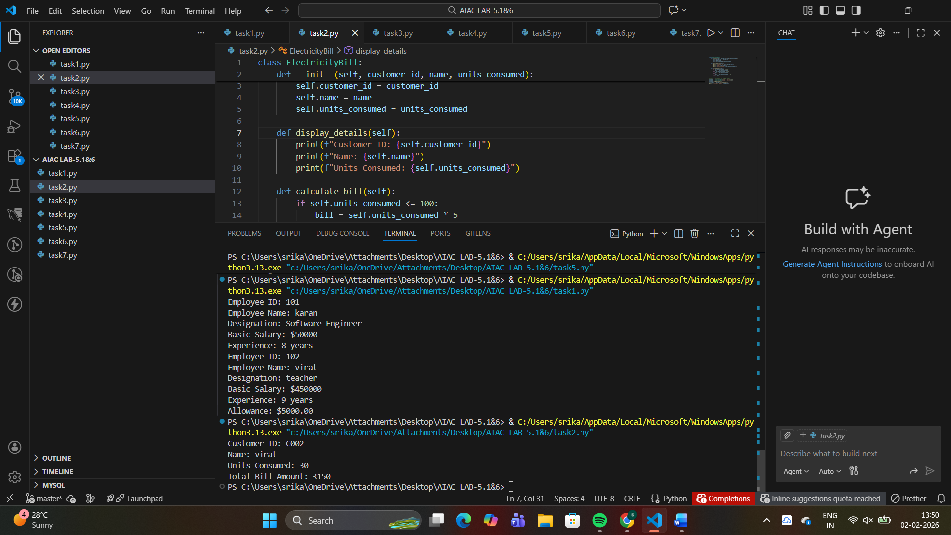
Task 3:
Product Discount Calculation- Create Python code that defines a
class named `Product` with attributes: `product_id`, `product_name`,
`price`, and `category`. Implement a method `display_details()` to
print product details. Implement another method
`calculate_discount()` where:
- Electronics → 10% discount
- Clothing → 15% discount
- Grocery → 5% discount
Create at least one product object, display details, and print the final
price after discount.
#ANS
class Product:
def __init__(self, product_id, product_name, price, category):
self.product_id = product_id
self.product_name = product_name
self.price = price
self.category = category

def display_details(self):
print(f"Product ID: {self.product_id}")
print(f"Product Name: {self.product_name}")
print(f"Price: ${self.price:.2f}")
print(f"Category: {self.category}")

def calculate_discount(self):
discount_rates = {
'Electronics': 0.10,
'Clothing': 0.15,
'Grocery': 0.05
}
discount = discount_rates.get(self.category, 0)
final_price = self.price * (1 - discount)
return final_price

# Example usage
product = Product(1, "Smartphone", 699.99, "Electronics")
product = Product(2, "shirt", 465, "Clothing")
product.display_details()
final_price = product.calculate_discount()
print(f"Final Price after discount: ${final_price:.2f}")
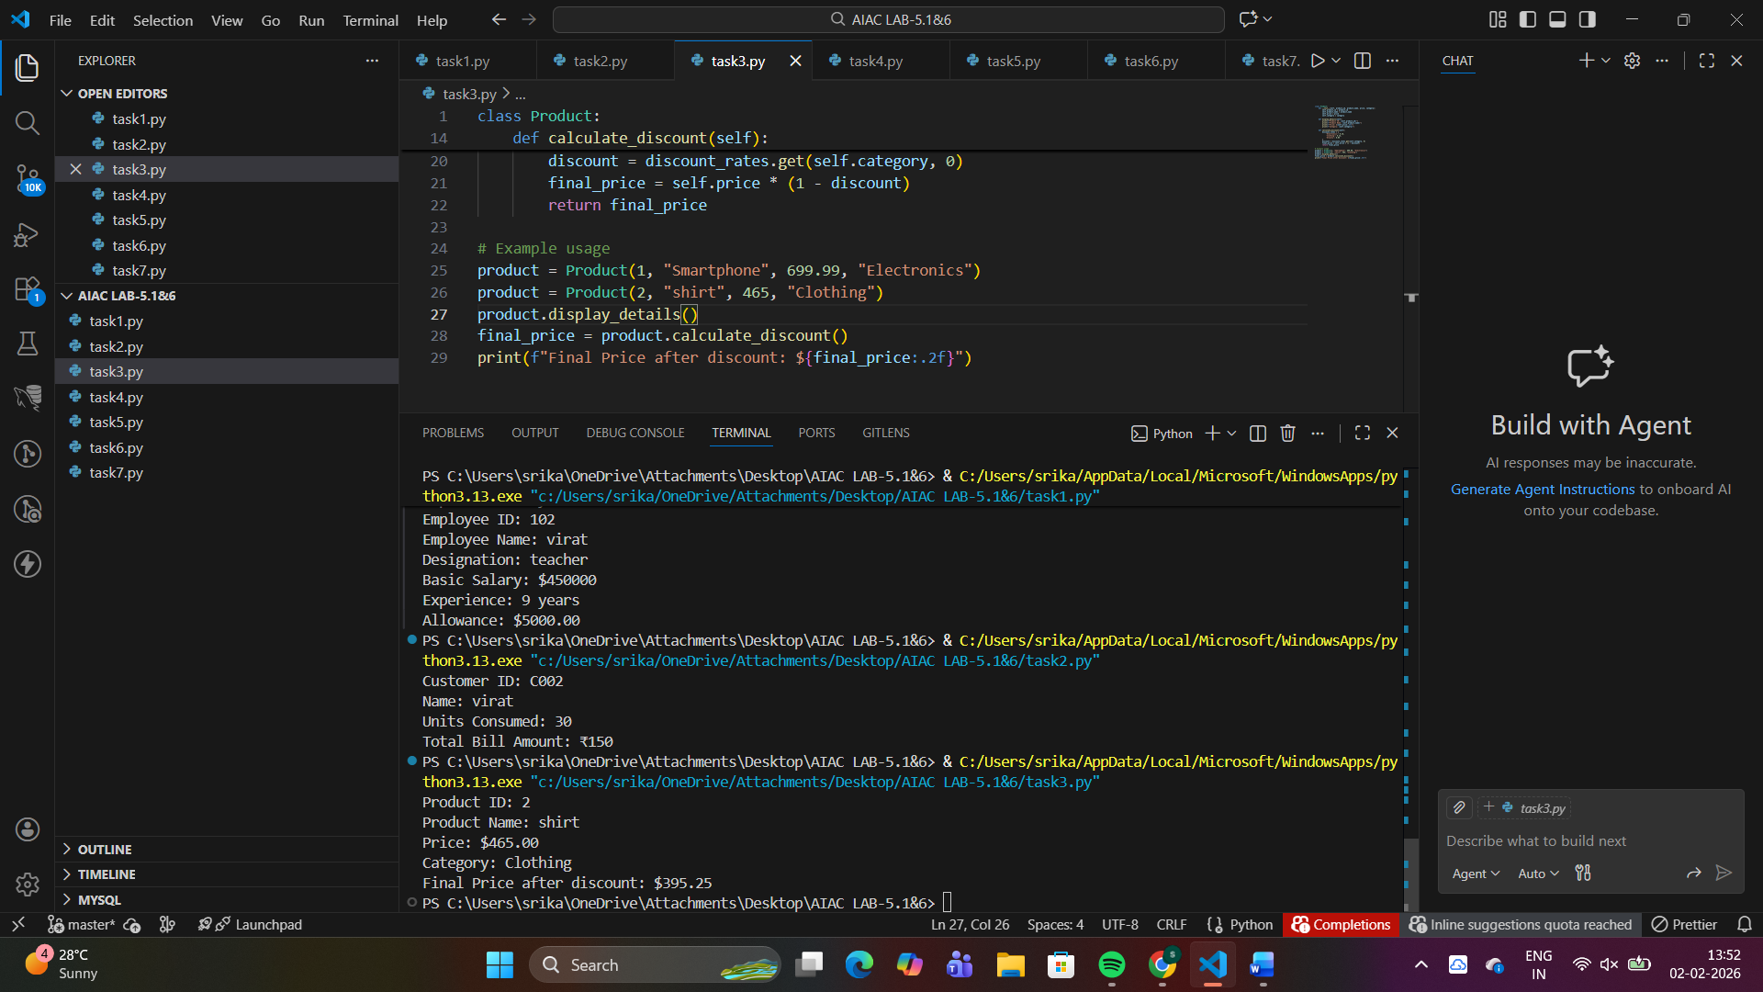
Task 4:
Book Late Fee Calculation- Create Python code that defines a class
named `LibraryBook` with attributes: `book_id`, `title`, `author`,
`borrower`, and `days_late`. Implement a method `display_details()`
to print book details, and a method `calculate_late_fee()` where:
- Days late ≤ 5 → ₹5 per day
- 6 to 10 days late → ₹7 per day
- More than 10 days late → ₹10 per day
Create a book object, display details, and print the late fee.
#ANS
class LibraryBook:
def __init__(self, book_id, title, author, borrower, days_late):
self.book_id = book_id
self.title = title
self.author = author
self.borrower = borrower
self.days_late = days_late

def display_details(self):
print(f"Book ID: {self.book_id}")
print(f"Title: {self.title}")
print(f"Author: {self.author}")
print(f"Borrower: {self.borrower}")
print(f"Days Late: {self.days_late}")

def calculate_late_fee(self):
if self.days_late <= 5:
return self.days_late * 5
elif 6 <= self.days_late <= 10:
return self.days_late * 7
else:
return self.days_late * 10

# Example usage
book = LibraryBook(1, "The Great Gatsby", "F. Scott Fitzgerald", "karan", 7)
book = LibraryBook(2, "fanisam", " ravindra", "prabhas", 34)
book.display_details()
late_fee = book.calculate_late_fee()
print(f"Late Fee: ₹{late_fee}")
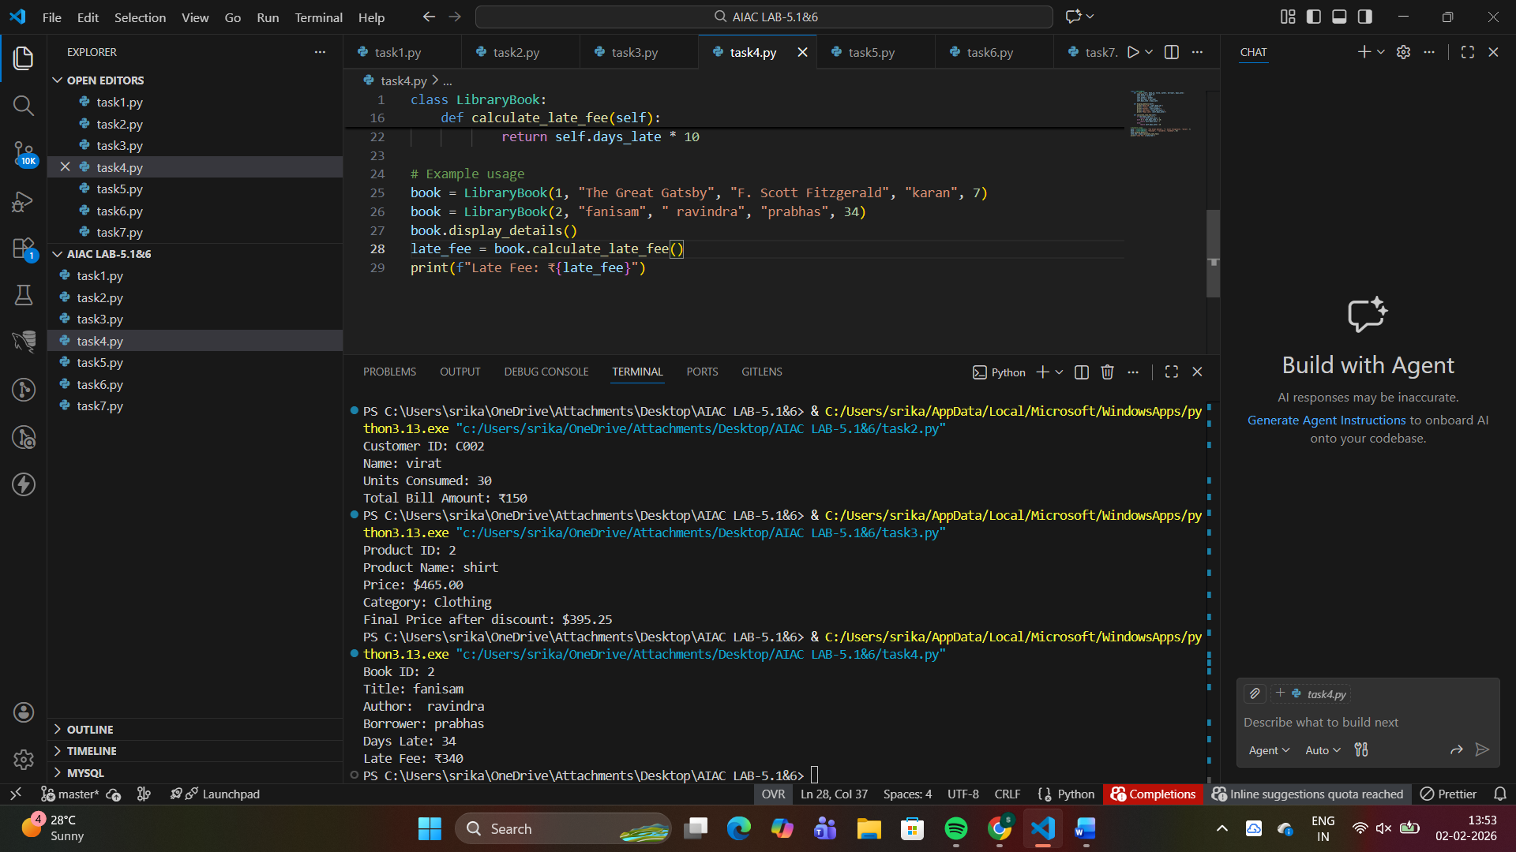
Task 5:
Student Performance Report - Define a function
`student_report(student_data)` that accepts a dictionary containing
student names and their marks. The function should:
- Calculate the average score for each student
- Determine pass/fail status (pass ≥ 40)
- Return a summary report as a list of dictionaries
Use Copilot suggestions as you build the function and format the
Output
#ANS
def student_report(student_data):

report = []

for student_name, marks in student_data.items():
average_score = sum(marks) / len(marks) if marks else 0
status = "Pass" if average_score >= 40 else "Fail"

report.append({
"name": student_name,
"average": round(average_score, 2),
"status": status,
"marks": marks
})

return report

# Example usage
if __name__ == "__main__":
students = {
"Alice": [85, 90, 78],
"Bob": [45, 50, 42],
"Charlie": [30, 35, 28],
"Diana": [92, 88, 95]
}

result = student_report(students)
for report in result:
print(f"{report['name']}: Avg={report['average']}, Status={report['status']}")
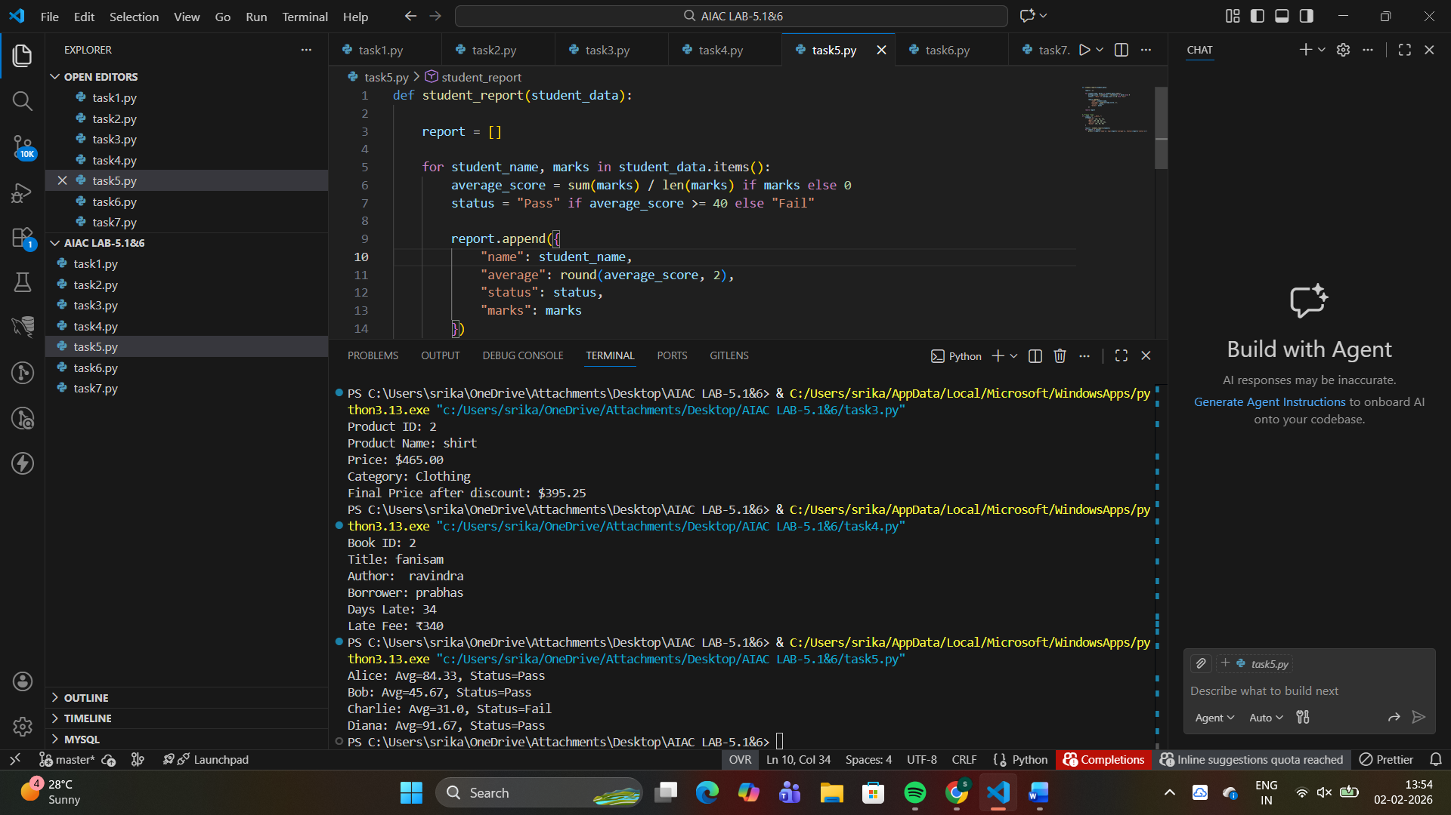
Task 6:
Taxi Fare Calculation-Create Python code that defines a class named
`TaxiRide` with attributes: `ride_id`, `driver_name`, `distance_km`,
and `waiting_time_min`. Implement a method `display_details()` to
print ride details, and a method `calculate_fare()` where:
- ₹15 per km for the first 10 km
- ₹12 per km for the next 20 km
- ₹10 per km above 30 km
- Waiting charge: ₹2 per minute
Create a ride object, display details, and print the total fare.
#ANS
class TaxiRide:
def __init__(self, ride_id, driver_name, distance_km, waiting_time_min):
self.ride_id = ride_id
self.driver_name = driver_name
self.distance_km = distance_km
self.waiting_time_min = waiting_time_min

def display_details(self):
print(f"Ride ID: {self.ride_id}")
print(f"Driver Name: {self.driver_name}")
print(f"Distance: {self.distance_km} km")
print(f"Waiting Time: {self.waiting_time_min} minutes")

def calculate_fare(self):
distance_fare = 0
remaining_distance = self.distance_km

# First 10 km at ₹15 per km
if remaining_distance <= 10:
distance_fare = remaining_distance * 15
else:
distance_fare = 10 * 15
remaining_distance -= 10

# Next 20 km at ₹12 per km
if remaining_distance <= 20:
distance_fare += remaining_distance * 12
else:
distance_fare += 20 * 12
remaining_distance -= 20

# Above 30 km at ₹10 per km
distance_fare += remaining_distance * 10

waiting_charge = self.waiting_time_min * 2
total_fare = distance_fare + waiting_charge

return total_fare

# Create a ride object
ride = TaxiRide("TX001", "John Doe", 35, 10)

# Display details
ride.display_details()

# Calculate and print fare
total_fare = ride.calculate_fare()
print(f"\nTotal Fare: ₹{total_fare}")
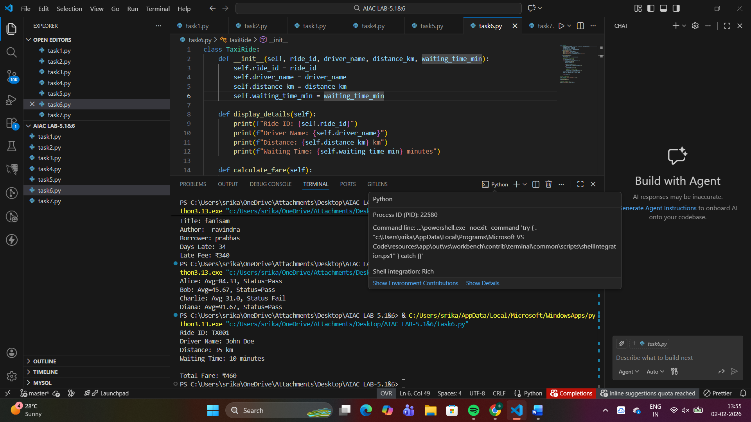
Task 7:
Statistics Subject Performance - Create a Python function
`statistics_subject(scores_list)` that accepts a list of 60 student scores
and computes key performance statistics. The function should return
the following:
- Highest score in the class
- Lowest score in the class
- Class average score
- Number of students passed (score ≥ 40)
- Number of students failed (score < 40)
Allow Copilot to assist with aggregations and logic
#ANS
def statistics_subject(scores_list):

highest = max(scores_list)
lowest = min(scores_list)
average = sum(scores_list) / len(scores_list)
passed = sum(1 for score in scores_list if score >= 40)
failed = sum(1 for score in scores_list if score < 40)

return {
'highest': highest,
'lowest': lowest,
'average': round(average, 2),
'passed': passed,
'failed': failed
}

# Example usage
if __name__ == "__main__":
scores = [45, 67, 23, 89, 56, 78, 34, 92, 61, 38] + [50] * 50
result = statistics_subject(scores)
print(result)
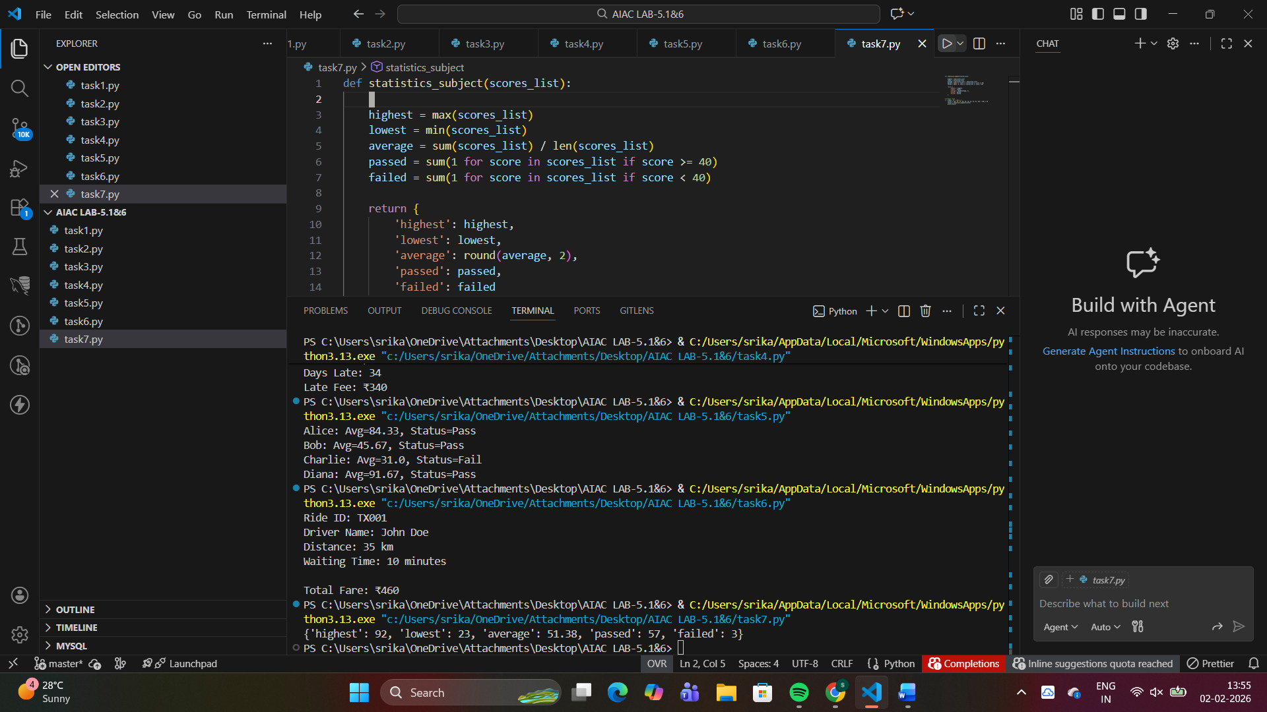
Task Description #8 (Transparency in Algorithm Optimization)
Task: Use AI to generate two solutions for checking prime numbers:
• Naive approach(basic)
• Optimized approach
Prompt:
“Generate Python code for two prime-checking methods and explain
how the optimized version improves performance.”
Expected Output:
• Code for both methods.
• Transparent explanation of time complexity.
• Comparison highlighting efficiency improvements.
#ANS
#prompt
Generate a python code to check prime numbers in naiva and optimazed approach
# Naive approach - check all numbers up to n-1
def is_prime_naive(n):
if n < 2:
return False
for i in range(2, n):
if n % i == 0:
return False
return True

# Optimized approach - check up to sqrt(n)

def is_prime_optimized(n):
if n < 2:
return False
if n == 2:
return True
if n % 2 == 0:
return False
for i in range(3, int(math.sqrt(n)) + 1, 2):
if n % i == 0:
return False
return True
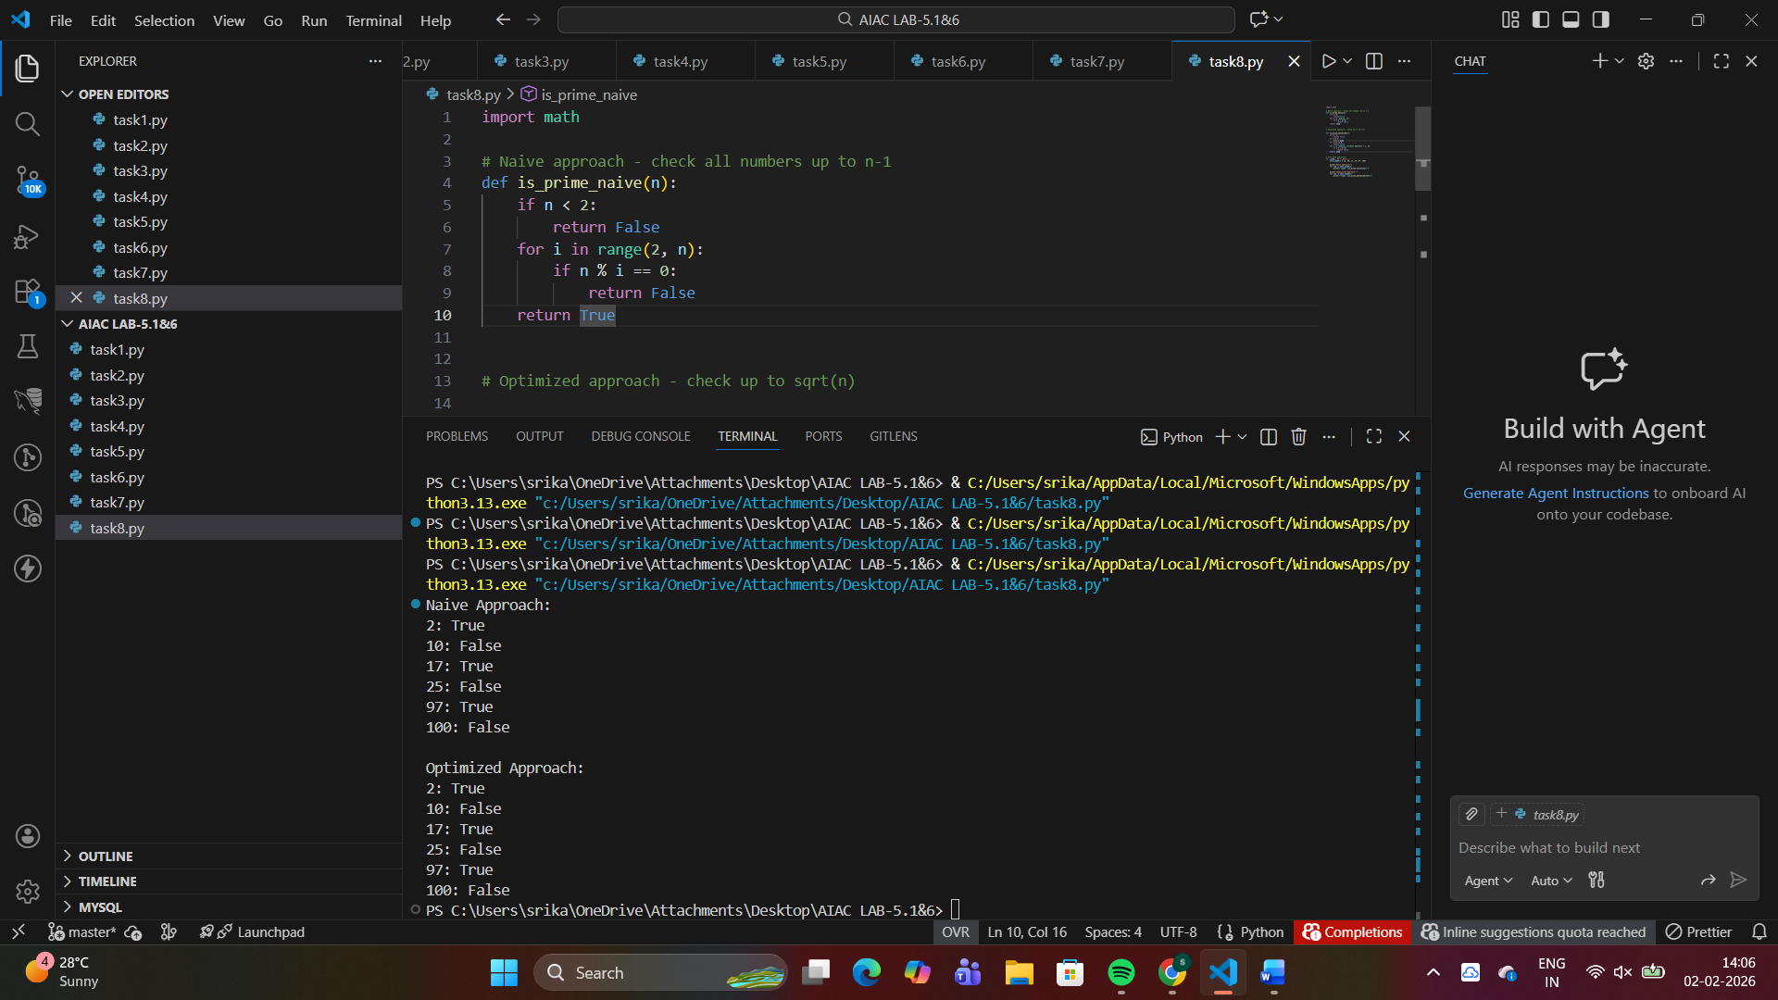
Time Complexity
- O(n)
- In the worst case (when n is prime), the loop runs n-2 times
Time Complexity
- O(√n)
Feature | Naive Approach | Optimized Approach
Loop Range | 2 → n-1 | 2 → √n
Time Complexity | O(n) | O(√n)
Efficiency | Low | High
Suitable for Large Numbers | No | Yes
Task Description #9 (Transparency in Recursive Algorithms)
Objective: Use AI to generate a recursive function to calculate
Fibonacci numbers.
Instructions:
1. Ask AI to add clear comments explaining recursion.
2. Ask AI to explain base cases and recursive calls.
Expected Output:
• Well-commented recursive code.
• Clear explanation of how recursion works.
• Verification that explanation matches actual execution.
#prompt
#generate python code that develop Fibonacci sequence using recursion
#provide well commented explanation in each line
# Function to calculate Fibonacci number at position n using recursion
def fibonacci(n):
# Base case 1: If n is 0, return 0 (first Fibonacci number)
if n == 0:
return 0
# Base case 2: If n is 1, return 1 (second Fibonacci number)
elif n == 1:
return 1
# Recursive case: Sum of the two previous Fibonacci numbers
else:
return fibonacci(n - 1) + fibonacci(n - 2)

# Main code to display Fibonacci sequence
# Prompt user to enter how many numbers they want in the sequence
num_terms = int(input("Enter the number of terms in Fibonacci sequence: "))

# Print header
print(f"Fibonacci Sequence up to {num_terms} terms:")

# Loop through each position in the sequence
for i in range(num_terms):
# Call fibonacci function and print the result
print(fibonacci(i), end=" ")

# Print newline at the end
print()
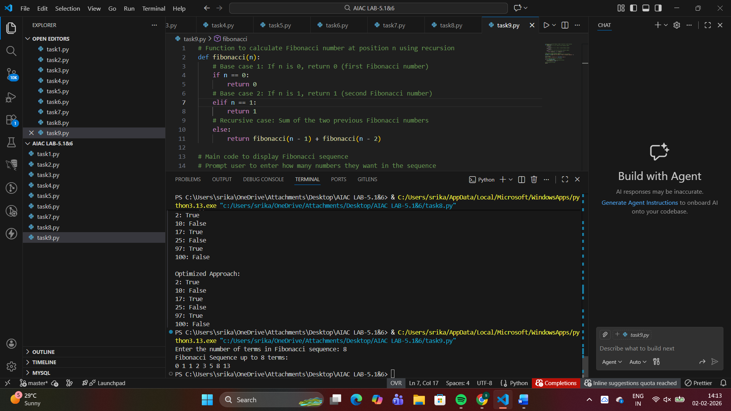
Task Description #10 (Transparency in Error Handling)
Task: Use AI to generate a Python program that reads a file and
processes data.
Prompt:
“Generate code with proper error handling and clear explanations for
each exception.”
Expected Output:
• Code with meaningful exception handling.
• Clear comments explaining each error scenario.
• Validation that explanations align with runtime behavior.
#prompt
#generate a python code that reads a file and process the data and explain each line meaningfully
def read_and_process_file(filename):
"""
Reads a file and processes each line of data.

Args:
filename (str): Path to the file to read
"""
try:
with open(filename, 'r') as file:
for line_num, line in enumerate(file, 1):
processed_line = line.strip()
if processed_line: # Skip empty lines
print(f"Line {line_num}: {processed_line}")
# Add your data processing logic here
except FileNotFoundError:
print(f"Error: File '{filename}' not found.")
except Exception as e:
print(f"Error reading file: {e}")

if __name__ == "__main__":
filename = input("Enter the filename: ")
read_and_process_file(filename)
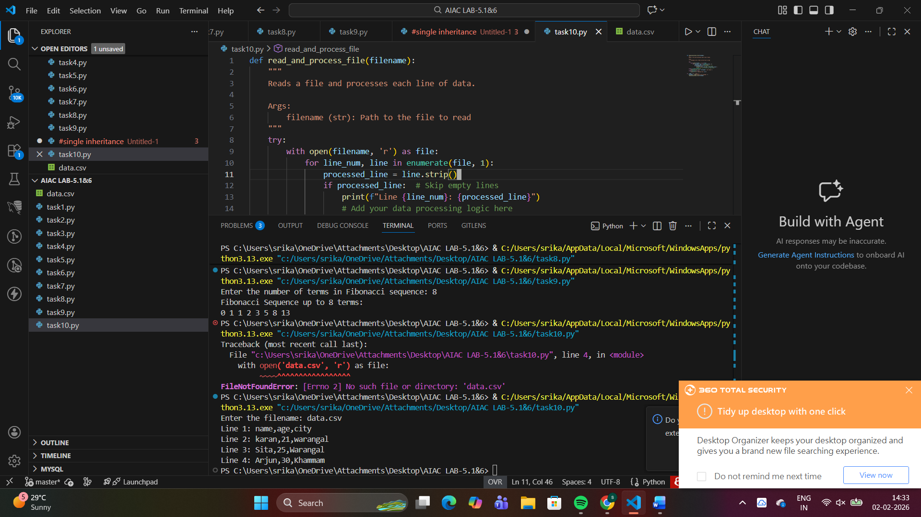
#Filenotfound
read_and_process_file("missing.txt")
Error: File not found. Please check the file name or path.
Program execution completed.
#permissionerror
Error: You do not have permission to read this file.
Program execution completed.
#valueerror
10
abc
30
Error: File contains non-numeric data.
Program execution completed.
Exception
Cause: Any unexpected runtime issue
Prevents program crash
Displays useful debugging info
###Error handling in Python uses try-except blocks to handle runtime errors gracefully without terminating the program.

